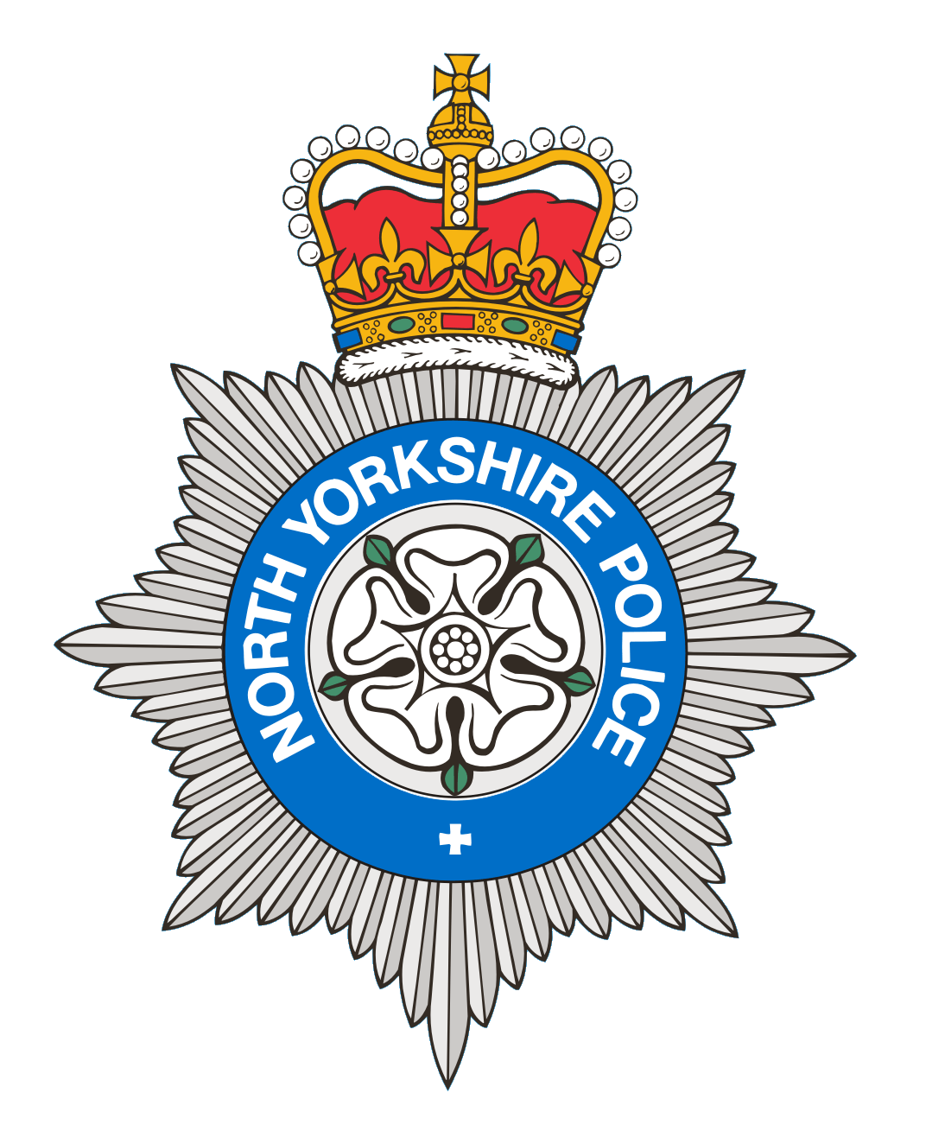
PCSO 3521 Diane Smith
Produced: 16th June 2025
Date of meeting- 17th June 2025

BROUGH WITH ST GILES
PARISH COUNCIL MEETING 17th June 2025
POLICE REPORT

18/04/2025 – 16/06/2025

Please note that under the police crime reporting system, all reports of criminal activity are recorded as crimes. However, if at a later date it is ascertained that no crime has been committed, this will not show on parish council report due to time delay.

Crimes = 2
2 Reports of Stalking/harassment
Reported crime for the same period last year = 9

Anti-Social Behaviour = 4
3 ASB Nuisance – 1 Report of Graffiti. 1 Report of youths on a roof. 1 Report of teenagers being rowdy having a house party.
1 ASB Personal – Report of issues with a neighbour.
Reports of ASB for the same period last year = 5

2 Administration – 1 Report of dog fouling. 1 Report of information from the public.
1 Road Traffic Collision - which was damage only
4 Road Related Incidents - 2 reports of possible drink driving. 2 Report of vehicles with no MOT.
Other reports for the same period last year= 7

Personal/Safety/Warning Incidents = 7

2 Reports of concern - 1 Report for a male who was given support and advice. 1 Report of Youths on a roof.

2 Reports of Suspicious behaviour – Information received from Member of the public. 1 Report of males on the building site who checked out to be all in order.

3 Reports of Domestic Incidents.

Other reports for the same period last year = 10

Community Messaging
North Yorkshire Community Messaging allows members of the public to register to receive alerts, crime notifications and community news from organisations. It is a way of maintaining contact with Neighbourhood Watch and Rural Watch groups. Neighbourhood & Rural Watch have their own database within community messaging for their members.

​You can sign up to receive alerts as a member of the public here:
https://www.northyorkshirecommunitymessaging.co.uk/

If you wish to speak to your local Neighbourhood PCSO you can send an e-mail to PCSO3521 Diane Smith diane.smith@northyorkshire.police.uk phone 101, choose option 2, and follow the prompts.

